# Software Requirement Specification

**PROJECT BRIEF**

**Project:** Ticket Booking System for Blue Line Travel Ltd.

**Date:** 27/12/2021

**By:** Team 1

**Client:** Blue Line Travel Ltd.

**Document Ref:** Project_Brief_01

**Version:** 1  
  
  
**Batch Name:** TECHBEE_OND21_APPS_FS_JAVA_2

**Trainer’s Name:** Mr. Balakrishna Palla Sir

# 

# Table of Contents

**Table of Contents** 2

1. **Project Brief History**. 3

1.1. Document Location 3

1.2. Revision History 3

1.1. Approvals 3

1.1. Distribution 4

2. **Introduction**. 5

2.1. Purpose 5

2.2. Background 5

2.1. Project Scope 6

3. **Project Brief** 6

3.1. Project Proposed by Client 6

4**. Design and Detailed Technical Updates** 7

4.1 Process Model – Use Case Model 7

4.2 Architecture Diagram 12

4.3 Software Requirement 13

4.4 Sequence Diagram 14

4.5 Database Design Changes 15

4.1.1 Entity Relationship Diagram 15

4.1.2 User Class Diagram 16

5. **Other Technical Details** 17

5.1 List of Impacted Modules 17

5.2 Scope of Change 17

6. **Additional Details** 17

6.1 Intended Audience and Reading Suggestions 17

# 1 Project Brief History

## 

**1.1 Document Location**

This document is only valid on the day it was printed.

The source of the document will be found on the project's PC in location

## 

**1.2 Revision History**

Date of this revision: 07/01/2022

## 

**1.3 Approvals**

This document requires the following approvals.

Signed approval forms are filed in the Management section of the project files.

|  |  |  |  |
| --- | --- | --- | --- |
| **Name** | **Signature** | **Designation** | **Date** |
| Mr. Balakrishna Reddy |  | Trainer | 09/01/2022 |
| Mr. Manmeet Jalota |  | Senior Manager | 09/01/2022 |

## 

**1.4 Distribution**

This document has been distributed to:

|  |  |  |  |
| --- | --- | --- | --- |
| **Name** | **Title** | **Sap-ID** | **Date** |
| Mr. Balakrishna Reddy | Trainer | 52003640 | 09/01/2022 |
| Mohd Asif Ansari | Project Manager | 51965910 | 09/01/2022 |
| Mohit Khatri | Team Member | 51968395 | 09/01/2022 |
| Abhishek Kumar | Team Member | 51961937 | 09/01/2022 |
| Shruti Sinha | Team Member | 51961953 | 09/01/2022 |
| Hrushikesh Sahoo | Team Member | 51969617 | 09/01/2022 |
| Rahul Kumar | Team Member | 51903052 | 09/01/2022 |
| Daksh Jain | Team Member | 51973660 | 09/01/2022 |

# 2. INTRODUCTION

**2.1 Purpose**

The Project Initiation Document (PID), contains further explanation regarding the ongoing project.  
  
The project brief contains the objectives, and the scope of the project as well as the various software & technology required for the development of the project. This document forms a contract between the two parties, project management team and the client Blueline Travels Ltd, Noida.  
   
The purpose of this document is to give you an overview of the online ticket management system for Blueline travels ltd. This system will help their customers to book ticket easily and quickly.

**2.2 Background**

Blueline travels is a market leader in Indian online travel sector. It is a Noida based company which provides online travel services in major cities of India. These services are airline tickets, rail and bus tickets.

As the owners have planned to expand their services to cover pan-India, a need of an advance and better ticket management system was unavoidable. Blueline travel previously had a ticket management system but that has its limitation. The interface was dull and unattractive, while the programs had many flaws and which was making it hard for the users to use the website, due to this they are seeing a down-trend in the website traffic.

Therefore, the project management team proposed them a new ticket management system which will developed as a user friendly web application, which will allow the users of blueline travels to access it anytime from anywhere and book ticket without any hassle.

**2.3 Project Scope**

The purpose of the ticket management system is to ease ticket management and to create a convenient and easy-to-use application for passengers, trying to buy tickets. The system is based on relational database with its various functions for reservation of flight, train, bus tickets.

The database connected with the train ticket reservation can be connected with the server of IRCTC to get real-time status of the seat availability. The same would be done with the databases of bus and flight ticket booking databases, they could be connected to various private as well as state buses server to get real-time updates. And as for the flights the database handling that could be connected to various domestic and international airline's server. Above all, we hope to provide a comfortable user experience along with the best pricing available.

**3. Project Brief**

**3.1 Project Proposed by Client**The requirement proposed by Blue Line travels are

* A secure and stable login and sign-up page
* A flight ticket reservation page
* A train ticket reservation page
* A bus ticket reservation page
* A secure payment system for purchasing the ticket
* Printing the booked ticket receipt
* Checking travel history
* Checking the future reservations

# 

**4. Design and Detailed technical updates**

**4.1 Process Model** **- Use Case Model**  
 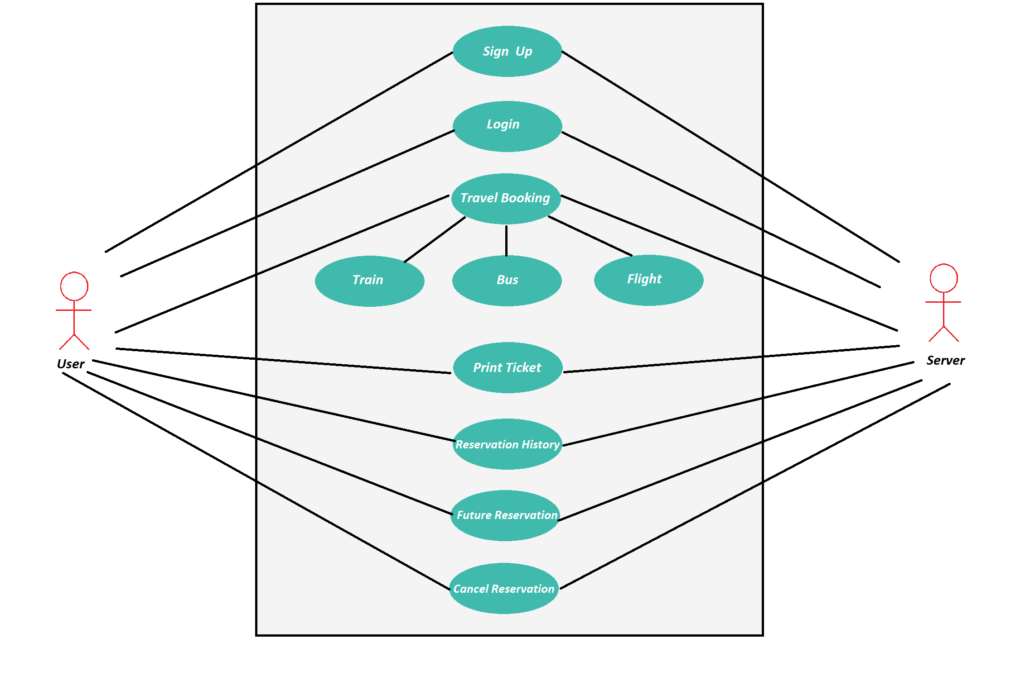

|  |  |
| --- | --- |
| Brief Description | User Sign-Up |
| Basic Flow | This use case describes how a user register in to the system   1. The user has to register himself/herself into the system. 2. After the successful registration, user will get a success message. 3. The following information is required during registration.  * Name   + First name   + Last name * Username * Password * Id Proof * Mobile Number * Email |
| Alternate Flow | The system will validate the information provided. If any invalid data is found, the input form will be redirected with error message. |
| Validation | 1. Name is required and minimum 3 characters and max 30 characters. 2. Username can be alphanumeric and must be unique. 3. Password should be minimum 8 characters with combination of upper and lower case alphabets and 1 digits or special character. 4. The Mobile number should be valid. 5. The Email should be valid. 6. Age should be minimum 18. |
| Pre-Conditions | User should have network access and Browser with latest updates. |
| Post-Conditions | Success message should be shown. |

|  |  |
| --- | --- |
| Brief Description | User Login |
| Basic Flow | This use case describes how a user log-in in to the system   * The user has to first sign-up himself into the system. * After the successful login, user will be taken to the appropriate landing page. * The following information is required to login. * Username * Password |
| Alternate Flow | The system will validate the credentials provided. If credentials are invalid, login form will be redirected again with error message. |
| Validation | 1. Valid Username 2. Valid Password |
| Pre-Conditions | User should have done the sign-up registration. |
| Post-Conditions | Home page will be displayed. |

|  |  |
| --- | --- |
| Brief Description | Bus Ticket Booking |
| Basic Flow | This use case describes how a user can book a bus ticket.   1. The user has to select the starting location, the destination and the date of journey. 2. After the successful selecting locations, user will be shown the available buses on the particular date. 3. The user can then book ticket in any available bus. |
| Alternate Flow | The system will redirect the user to the payment page. |
| Validation | 1. Valid Starting location 2. Valid Destination |
| Pre-Conditions | User should have successfully login into the system. |
| Post-Conditions | Payment page has to be displayed. |

|  |  |
| --- | --- |
| Brief Description | Train Ticket Booking |
| Basic Flow | This use case describes how a user can book a train ticket.   1. The user has to select the starting location, the destination and the date of journey. 2. After the successful selecting locations, user will be shown the available train on the particular date. 3. The user can then book ticket in any available train. |
| Alternate Flow | The system will redirect the user to the payment page. |
| Validation | 1. Valid Starting location 2. Valid Destination |
| Pre-Conditions | User should have successfully login into the system. |
| Post-Conditions | Payment page has to be displayed. |

|  |  |
| --- | --- |
| Brief Description | Flight Ticket Booking |
| Basic Flow | This use case describes how a user can book a flight ticket.   1. The user has to select the starting location, the destination and the date of journey. 2. After the successful selecting locations, user will be shown the available flight on the particular date. 3. The user can then book ticket in any available flight. |
| Alternate Flow | The system will redirect the user to the payment page. |
| Validation | 1. Valid Starting location 2. Valid Destination |
| Pre-Conditions | User should have successfully login into the system. |
| Post-Conditions | Payment page has to be displayed. |

|  |  |
| --- | --- |
| Brief Description | Payment page |
| Basic Flow | This use case describes how a user can pay the required amount and book his ticket.   1. The user has to select the mode of payment. 2. After the successful selecting the mode, user will be asked to fill the appropriate information according to the mode of payment. 3. The user can then pay the required amount and book his ticket. |
| Alternate Flow | The system will redirect the user to the print ticket page. |
| Validation | 1. Valid payment mode. 2. Valid payment information |
| Pre-Conditions | User should have successfully provided the ticket information. |
| Post-Conditions | Print ticket page has to be displayed. |

|  |  |
| --- | --- |
| Brief Description | Print Ticket page |
| Basic Flow | This use case describes how a user can print the booked ticket.   1. The user has to click the print button. 2. After the successful clicking the button the ticket will be printed. |
| Alternate Flow | The system will redirect the user to the home page. |
| Validation | 1. Valid ticket information |
| Pre-Conditions | User should have successfully provided the ticket information. |
| Post-Conditions | Home page has to be displayed. |

|  |  |
| --- | --- |
| Brief Description | View Reservations |
| Basic Flow | This use case describes how a user can view his/her ticket reservation history and his upcoming journeys.   1. The user has to click the view journeys button. 2. After the successful clicking the button, the user will be redirected to the page showing his ticket reservation history and his upcoming journeys. |
| Alternate Flow | The system will redirect the user to the view reservation page. |
| Validation | * Valid login credentials. |
| Pre-Conditions | User should have successfully login into the system. |
| Post-Conditions | Home page has to be displayed. |

|  |  |
| --- | --- |
| Brief Description | Cancel Reservations |
| Basic Flow | This use case describes how a user can cancel his upcoming ticket reservation.   1. he user has to click the cancel reservation button. 2. After the successful clicking the button, the user will be redirected to the page showing his upcoming journeys. 3. The user can then enter the ticket information of the reservation that he/she wants to cancel. |
| Alternate Flow | The system will redirect the user to the home page. |
| Validation | 1. Valid ticket information. |
| Pre-Conditions | User should have successfully login into the system. |
| Post-Conditions | Home page has to be displayed. |

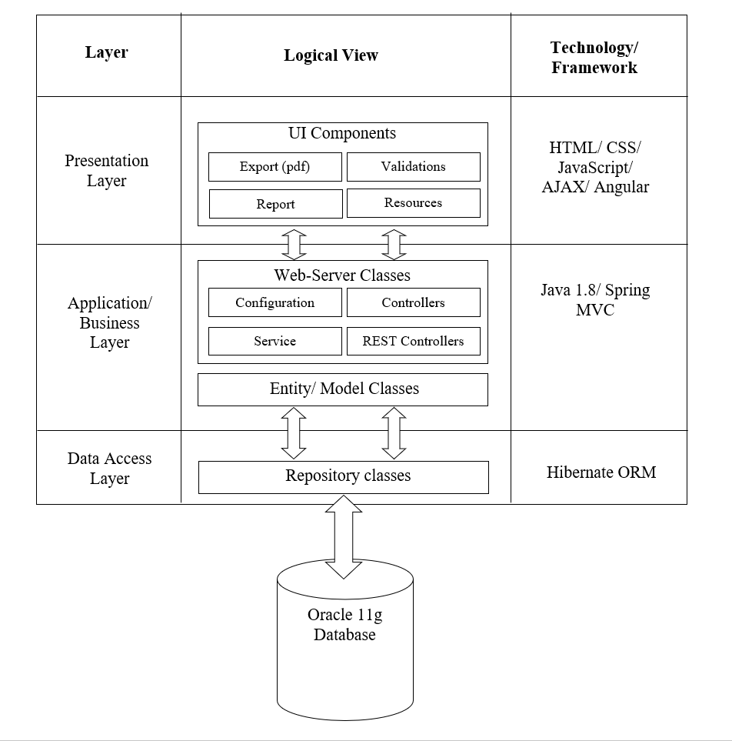**4.2. Architecture Diagram**

**Presentation Layer:**

This layer consists of all UI components.

* Export component: The plug-in is used to export the reports in pdf format. It helps to reduce the workload on the web/ application server.
* Validation component: All basic level data validations should be done at UI level.
* Report component: All reports to be generated to the user, will be processed and generated at the browser end.
* Resources: All HTML/CSS/ images, which are required for the page design.

**Application Layer:**

This layer comprises of all server and business classes.

* Configuration settings (XML or Class based) will define the application and server configuration.
* Spring Controllers defines the server classes, which are required to process the incoming http requests.
* Service classes are required to perform the required business services.
* REST Controllers to process the HTTP AJAX requests.
* Model classes are used the define the functions of the entities present in the system.

**Data Layer:**

Data layer is implemented through Hibernate ORM. It will contain the repository classes, which provides interface to the table.

**4.3 Software Requirement**

The system requirement for development of the system are as follows:

* Operating system- Windows 10
* Technology- java (J2EE)
* Web technologies- HTML, CSS, JavaScript
* IDE- Eclipse IDE, Sublime Text
* Database- Oracle 11G Express Edition
* Java version- JDK 8

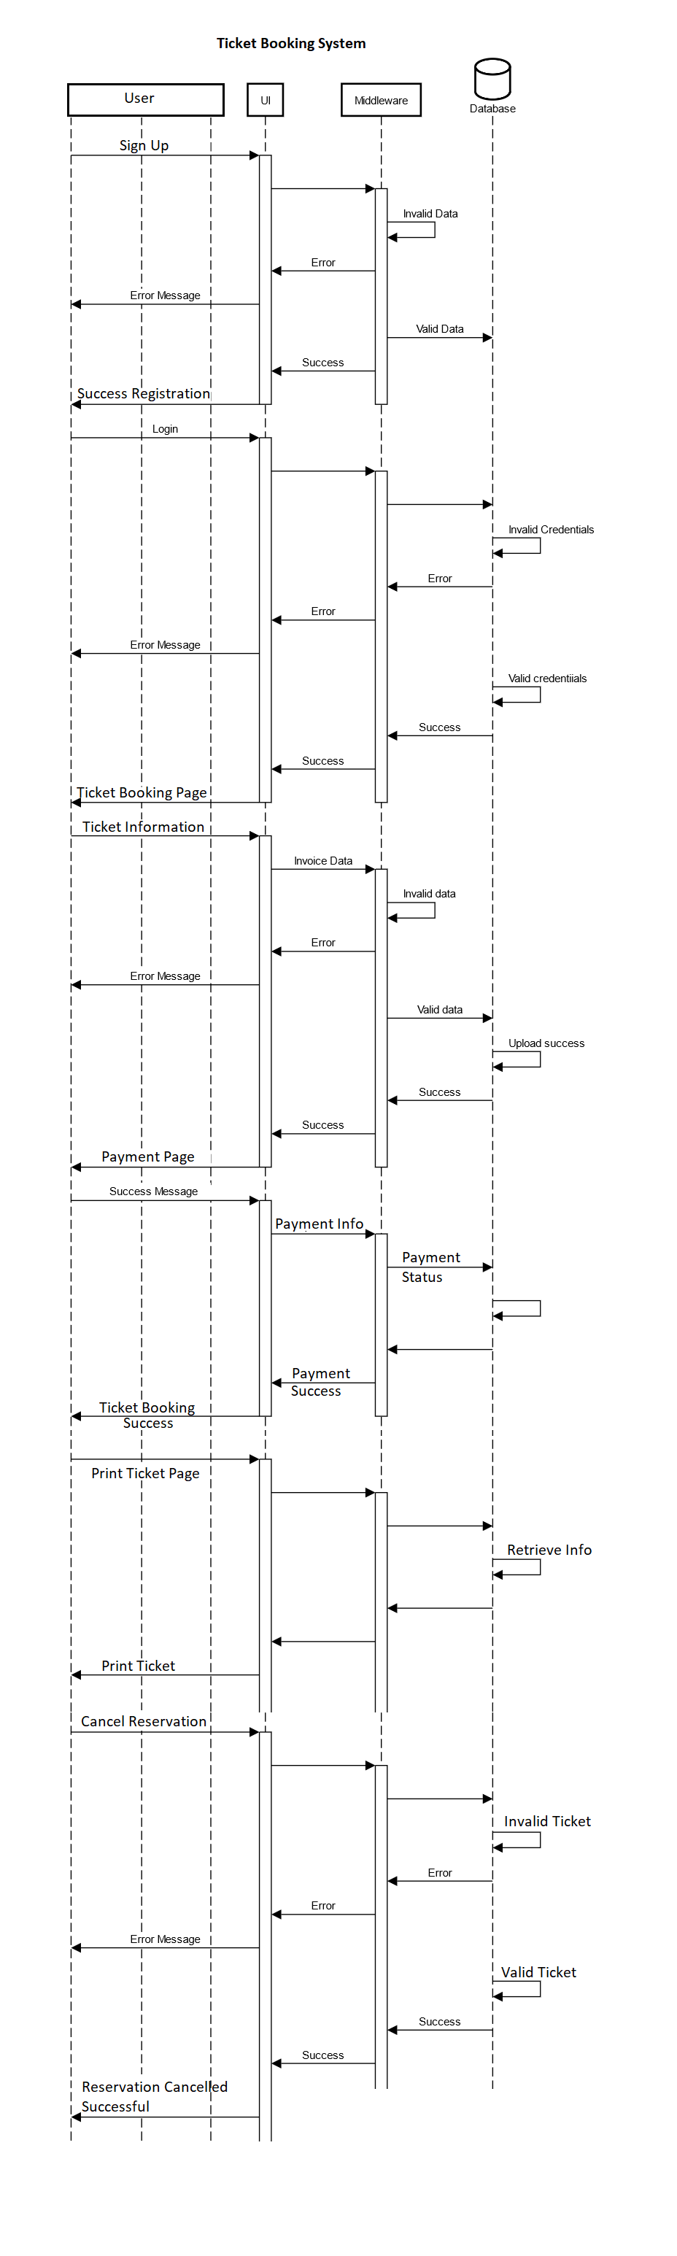 **4.4 Sequence Diagram**

**4.5 Database Design Changes**

**4.5.1 Entity Relationship Diagram**

]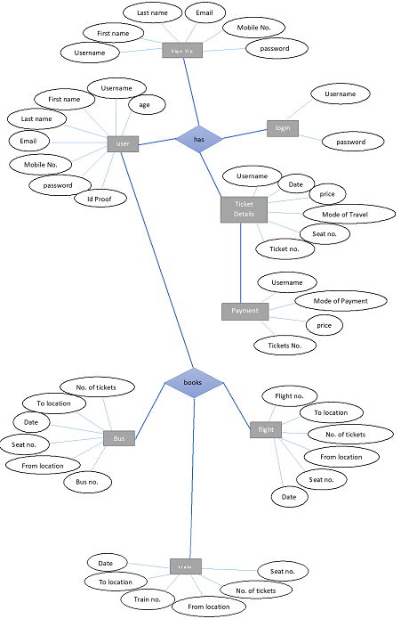

**4.5.2 User Class Diagram**

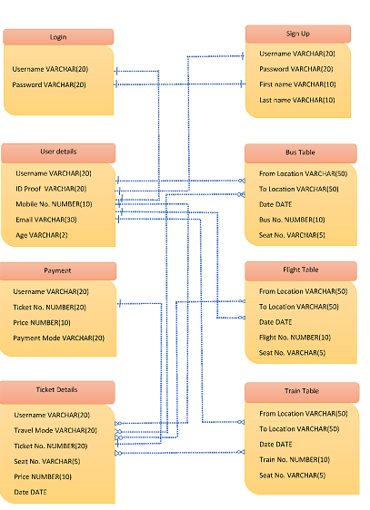

**5 Other Technical Details**

**5.1 List of Impacted Modules**

All the program functional modules will be created from scratch by the team.

**5.2 Scope of Change**

The system can be improved in the future by adding more functions like by adding more states and transport in the system. The system also lacks proper user verification and security measures like having a phone number and email verification and captcha puzzle to prevent bots.

**6 Additional details**

**6.1 Intended Audience and Reading Suggestions**

This document is for the ticket management system. This has been implemented under the guidance of Mr. Balakrishna Palla. This project is useful for the Blueline travels ltd and their users.